AM,S-PERU-Q’eros-Textiles-20th c

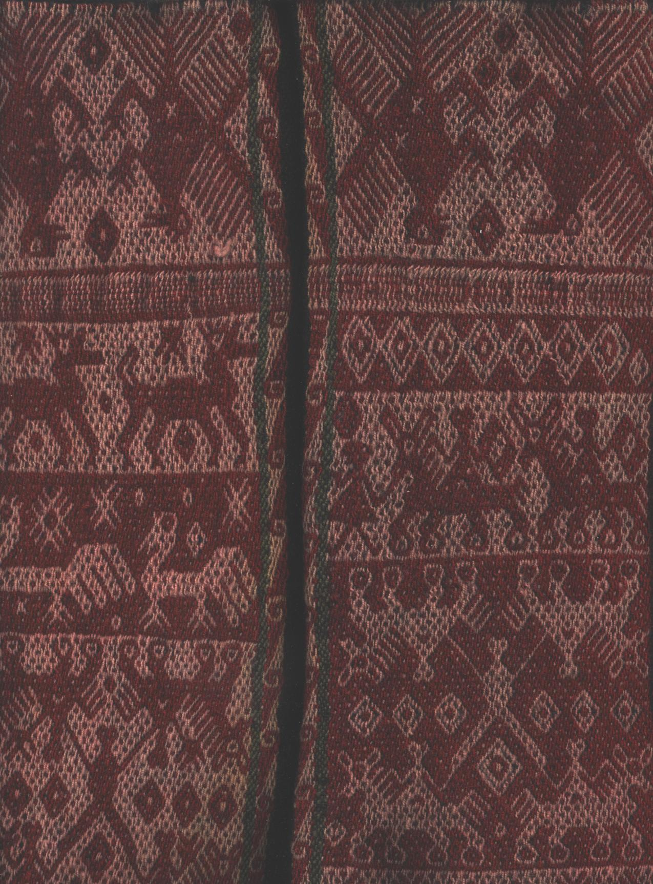

Case No.: Textiles

**Accession No.**

**Formal Label:**

**Display Description:**

The Q'ero people, who are perhaps the direct descendants of the Inka[1], are situated north of Cuzco between the Andes and the Amazon basin. They have maintained their Inkan cultural identity for more than 500 years despite the invasion by Spanish Conquistadors who attempted to destroy their empire and its religion through war and missionizing.

These *Mesa quepe* textiles or *Mastanas* (altar cloths) are used by Q'ero Paqos or “mystic-shamans” in a ceremony called *despacho, pago a la Pachamama* (“the office of paying homage to the ‘Cosmic Mother’”). The *Mesa quepe* was woven in the community of Huacawasi, located in the Calca or “Sacred valley” in the mountainous area north of Cuzco. This Mastana has interlocking geometrical designs in the form of birds and animals. Since these textiles are hand-loom woven the designs are reversible just as all life has another aspect to it.

The Paqos who use these *Mastanas* in their rituals are both quasi-mystics and quasi-shamans and share certain abilities of each. As mystics they have a spirituality that partakes of a direct, experience of non–duality, an interconnectedness of all beings. (A similar concept known as Indra’s net (*Indrajāla* in Sanskrit) is found in Indian philosophy deriving from a metaphor illustrating *pratītyasamutpāda*, dependent origination from the center of the Cosmos).

This concept may be visualized by a spider’s web after a rainfall:

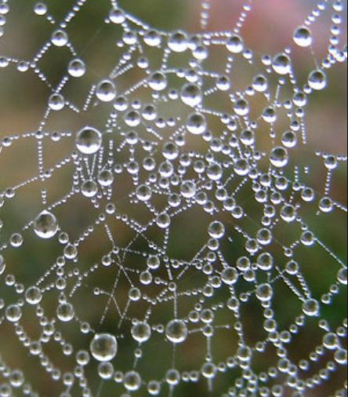

Water droplets suggest both the individuation and the interconnectedness of all Beings with the center from which they are both separate and a part. In the Inka world-view this mutually interactive and supportive relationship of the individual with the center of the Cosmos is mirrored in the interconnectedness of the individual withPachamama (Cosmic Mother Earth) and her *Apus* (mountain spirits), mythically envisioned in the high peaks of the Andean mountains. Since Incas *understand* their interconnectedness to Pachamama, they draw on Her power for spiritual energy for service to the community, within the context of *ayni,* the Incan principle where giving and receiving are reciprocal.

In Q’ero textiles images of creatures are geometrically interlocked, metaphorically alluding to the interdependence of all Beings. Like shamans, the Paqos develop access to esoteric abilities but unlike shamans they acquire these abilities without entering into altered states of consciousness through the use of psychoactive plants, rhythmic drumming, or group chanting: they derive esoteric abilities like promoting an alpaca’s fertilityby playing flutes and singing heterophonically, a practice that has been known empirically to effect the desired result.

**LC Classification:**

**Date or Time Horizon:**

**Geographical Area:**

**Map:**

**GPS coordinates:**

**Cultural Affiliation:**

**Media:**

**Dimensions:**

**Weight:**

**Condition:**

**Provenance:**

**Discussion:**

**References:**

**SIZE**: 32 X 34 inches

**MATERIAL**: Alpaca and llama wool

**CULTURE**: Quechua

**ORIGEN**: Cusco- Perú

**COLORS**: Red, burgundy, white, black, and  orange.

1. The spelling “Inka” is used here to reflect the indigenous spelling of the word rather than the more usual spelling “Inca” which was transliterated by the Spanish Conquistadors.